Contents
1 Introduction 4
1.1 Purpose and Scope 4
2 Design Overview 4
2.1 Component environment 4
2.2 Services required 6
2.2.1 From the Symbian OS subsystems 6
2.2.2 From the Baseband subsystems 6
2.2.3 From HW 6
2.3 Services provided 6
2.3.1 UI 6
2.3.2 SW IF 6
3 Detailed Design 7
3.1 Class diagrams 7
3.1.1 Framework 7
3.1.2 Component 10
3.2 Class descriptions 19
3.2.1 Structs, type definitions and enumerations 21
3.2.2 Flag definitions 21
3.2.3 State diagrams 22
3.3 Operations 22
3.3.1 Initializing a connection to the Baseband 22
3.3.2 Serving an ETel API request 22
3.3.3 Serving an ETel API notification request 24
3.4 Backup and Restore 25
4 IPC Naming Conventions 25
5 Caching Pattern 25
5.1 Requirements 25
5.2 Applying IPC naming conventions to caching IPCs 25
5.3 Get requests 26
5.4 Register requests and LTSY notifications 27
5.5 Legacy IPC handling 27
5.6 Cached data 28
5.6.1 Cache Ability state transitions (enabled/disabled/legacy) 29
5.6.2 Cache Status state transitions (clean/dirty) 29
6 Design Considerations 30
6.1 System resource usage 30
6.1.1 Files 30
6.1.2 Other data 30
6.2 Task allocation 30
6.3 Performance 30
6.4 Timers 30
7 Security 30
7.1 Capabilities of this component 30
7.2 Input and output validation 31
7.3 Additional enforcements 31
7.4 Variation 31
8 Usage 31
8.1 User's guide 31
8.1.1 From the ETel Server client point of view 31
8.1.2 From the Licensee TSY point of view 31
9 Introducing the CTSY Dispatcher 31
9.1 New Component View 32
9.2 CtsyDispatcher-LicenseeTSY Interface 33
10 Further Information 38
10.1 References 38
10.2 Open Issues 38
10.3 Glossary 38
10.4 Document History 38

Introduction
This document describes the design of the Common TSY module for Symbian.

Purpose and Scope
Common TSY is implemented to ease the integration work of Symbian software with the licensee specific Baseband. Common TSY is delivered to Symbian licensees as part of the Symbian delivery.
Common TSY is the provider module for the ETel Core, Multimode ETel and Packet Data APIs defined by Symbian Software Ltd., and the Multimode ETel Custom API defined by Symbian. Common TSY implements the upper layer of TSY and is designed to be independent of the Baseband and the Licensee TSY below. The Baseband and Licensee TSY should also be easily changeable or replaceable.
Common TSY also provides a plug-in interface implemented by licensees called “Telephony Audio Control,” It allows a licensee to control the setup and teardown of the telephony audio e.g. audio path based on when a call moves to and from idle states.
The tasks of Common TSY include, for example, saving information about the current status of the Baseband by using Symbian OS variable types, and saving information about the notifications that clients want to receive.

Design Overview

Component environment
Common TSY and ETel Server run in the same thread, which belongs to the communications process of the Symbian OS.
Figure 2.1 presents the logical context of Common TSY. The Common TSY module implements the abstract TSY interface specified by Symbian Software Ltd., which ETel Server uses to serve the ETel API requests that are made.
Phone Engine is considered as the main user of ETel Server APIs, but Common TSY does not restrict the usage of the APIs by other clients in any way.
The System State Manager API is used to set the RF state when the RF state is off, and an emergency call needs to be made.
The SIM ATK TSY component implements the SIM ATK (SIM Application Toolkit) related TSY features. Symbian licensees implement this component. In Symbian releases, there is a SIM ATK TSY stub available to replace the SIM ATK TSY implementation.
The Telephony Audio Control Plug in interface is implemented by licensees. It is triggered when a call is created or destroyed and also when calls change state.
The File Logging interface is used for test logging purposes.
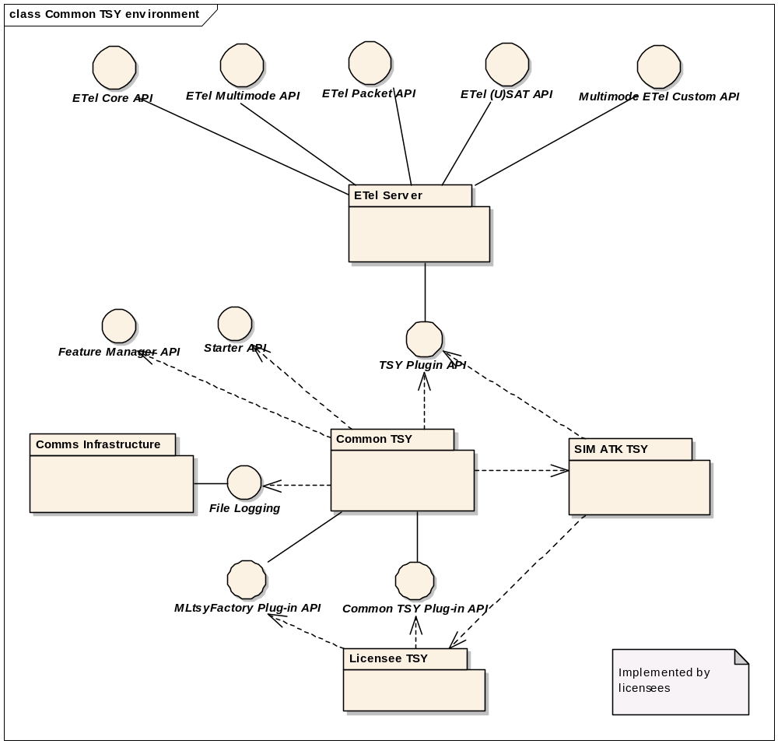
Figure 2.1 Common TSY environment
Common TSY consists of two DLLs as shown in Figure 2.2. PhoneTsy is a factory class which instantiates Licensee TSY, the Common TSY Plugin API and the Phone object in Common TSY.
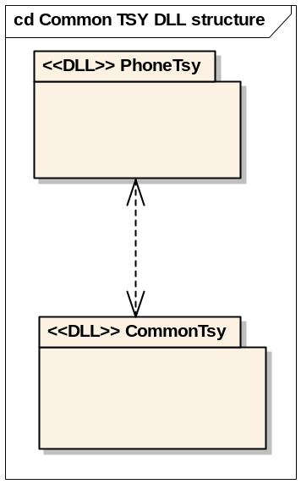
Figure 2.2 Common TSY DLL structure

Services required

From the Symbian OS subsystems
API | Description
TSY Plugin API | Common TSY implements the TSY Plugin API provided by ETel Server.
File Logging interface | The File Logging API is needed for tracing purposes.
System State Manager Interface | The System State Manager API provides services for setting RF on/off for an emergency call. This is needed in the Offline Mode implementation.
Feature Manager API | The Feature Manager API is used to variate different features in Symbian.

From the Baseband subsystems
This component has no interfaces to the Baseband side subsystems. In fact, it is vital that Common TSY is made as independent as possible of the Baseband specific features and functionalities.

From HW
This component has no direct HW interfaces.

Services provided

UI
Common TSY does not provide any user interface.

SW IF
Provided service | Description | Protected
Common TSY Plugin API | The Common TSY Plugin API is a plug-in API between Common TSY and Licensee TSY. | No
Telephony Audio Control Plugin API | The Telephony Audio Control Plugin API is a plug-in API between Common TSY and Licensee TSY. | No
ETel Core | The ETel Core API provides a basic set of telephony features to Symbian OS side clients. Common TSY implements the functionality described in this API (only the functionality supported by Symbian or a third party API). | Yes
ETel Multimode API | The ETel Multimode API provides a rich set of telephony features to Symbian OS side clients. Common TSY implements the functionality described in this API (only the functionality supported by Symbian or a third party API). | Yes
ETel Packet API | The ETel Packet API provides packet data related services to Symbian OS side clients. Common TSY implements the functionality described in this API (only the functionality supported by Symbian or a third party API). | Yes
Multimode ETel Custom API | The Multimode ETel Custom API is a Symbian extension to ETel APIs. | Yes

Detailed Design

Class diagrams
This section describes the static object model of the subsystem.

Framework
Figure 3.3 represents the simplified static model of Multimode TSY (Common TSY and Licensee TSY).
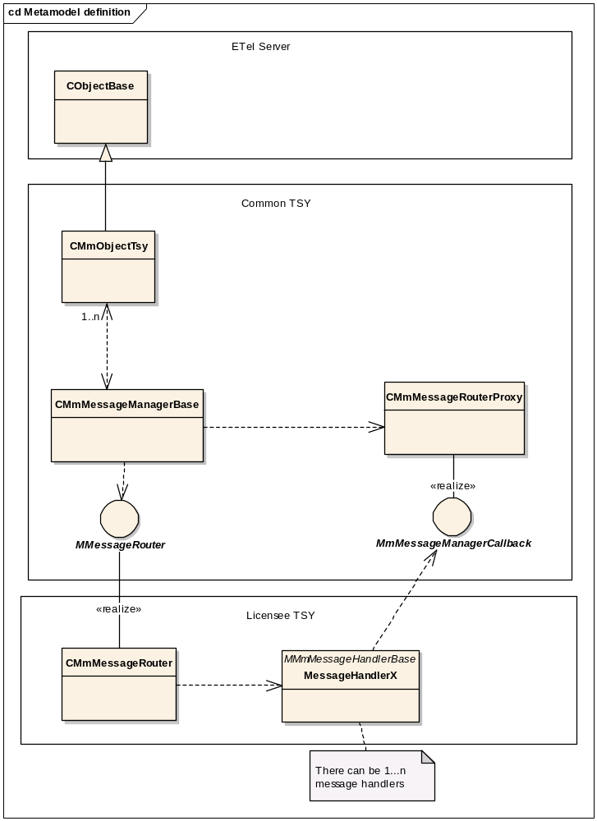
Figure 3.3 Metamodel definition
The TSY design is based on static DLLs and boot-time memory allocation. TSY is a single thread, and Licensee TSY should have only one Active Scheduler (for responses and indications coming from the Baseband). The following initial design principles give TSY maximum stability and reliability:
- Since the Common TSY DLL is static, loading of the DLL cannot fail.
- Memory allocation for status data (in Licensee TSY), a buffer for message sending to the Baseband, etc. are allocated during boot-up.
- There must be no concurrency/race conditions inside Common TSY.

Common TSY inherits its base classes (CMmObjectTsy object can be replaced by Phone, Line or Call) from ETel Server provided by Symbian OS. The main interfaces for Common TSY are:
- TSY Plugin API towards ETel Server. The TSY Plugin API is provided by Symbian OS, and Common TSY uses it to serve the client requests coming from ETel Server client interfaces.
- Common TSY Plugin API towards Licensee TSY. This API is provided by Common TSY and used for communication between Common TSY and Licensee TSY.

Error: Reference source not found represents the simplified static model of Telephony Audio Control.
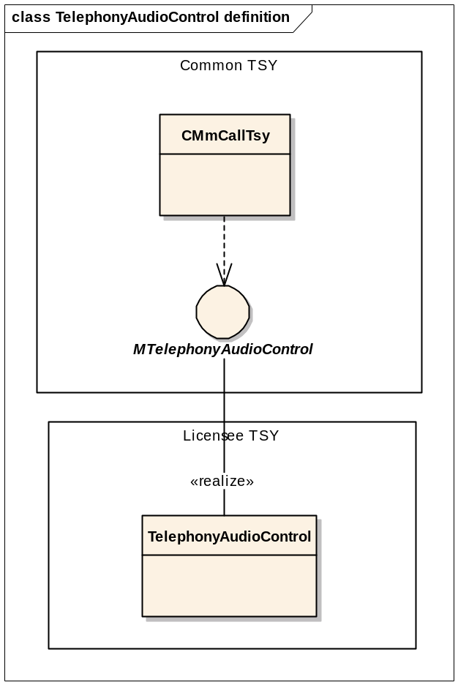
Figure 3.4 Telephony Audio Control metamodel definition.
The implementation of the Telephony Audio Control plug in interface is optional by licensees. The plug in interface is triggered when call is created or destroyed and also when calls moves between its states. The triggering is done both mobile terminated and mobile originated calls.

Component

Common TSY implementation
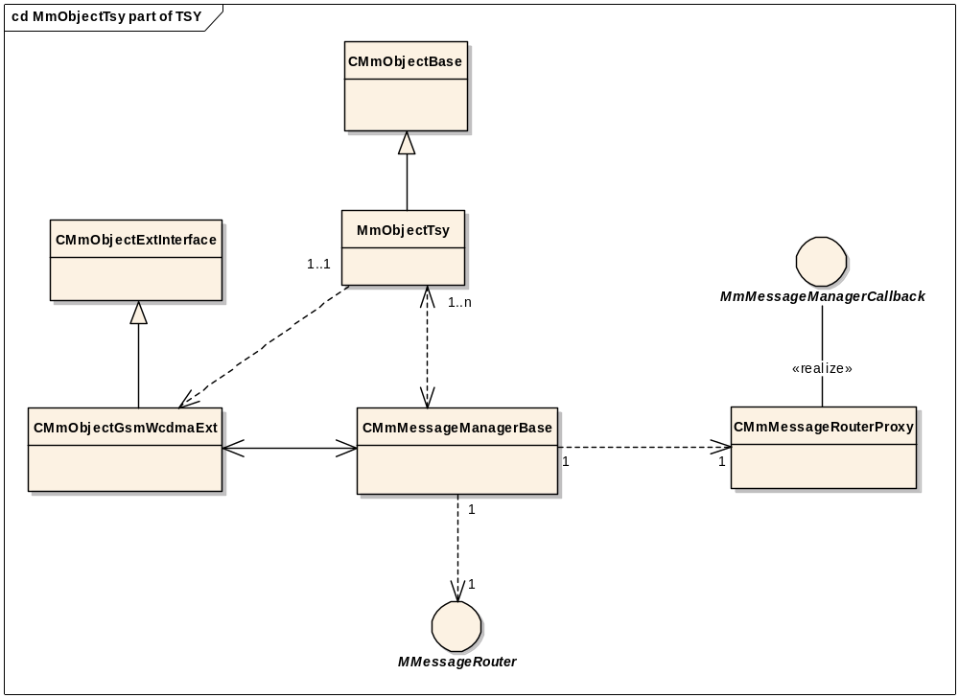
Figure 3.3 MmObjectTsy part of TSY
Figure 3.3 shows the Common TSY design of TSY in more detail. An object of type CMmObjectTsy handles the mode independent requests and requests that do not require interaction with the Baseband.
Mode specific Common TSY requests are delegated to the mode specific extensions (objects of type CMmObjectGsmWcdmaExt) that provide the mode specific implementation of features. The extension classes are inherited from abstract interface classes (of type CMmObjectExtInterface) providing transparent access to any protocol extension (for example, GSM, WCDMA) from CMmObjectTsy. The purpose of this design is to separate mode independent implementation from mode specific, since network related features vary between different protocol modes.
Both the mode independent objects and mode specific objects can access Licensee TSY using Message Manager.
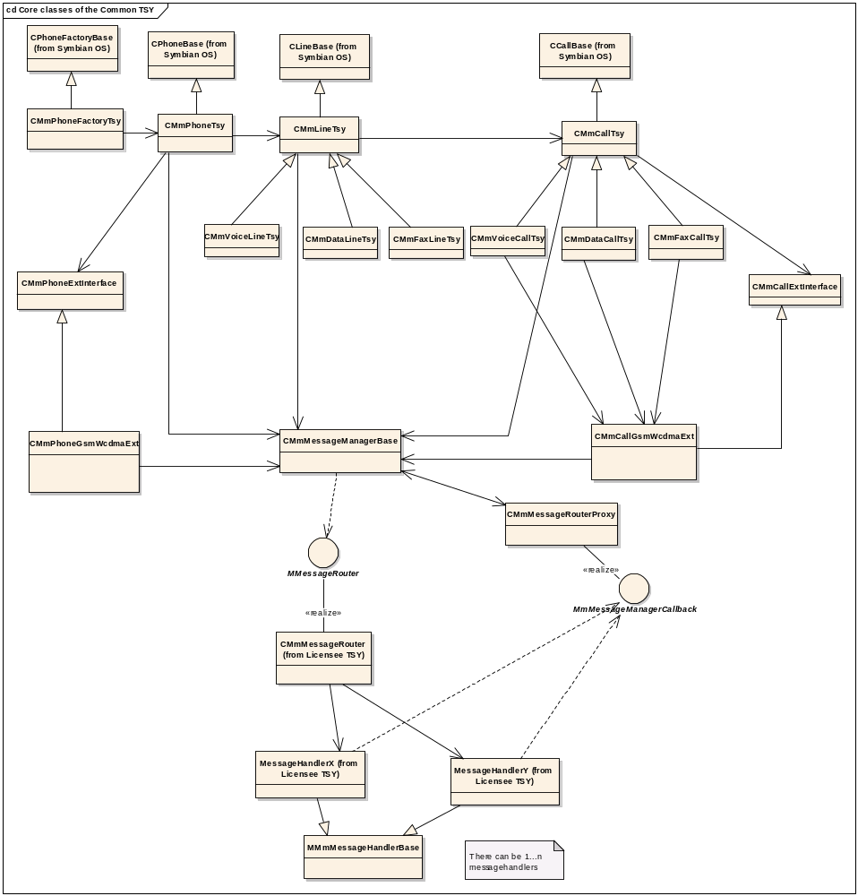
Figure 3.4 Core classes of the Common TSY
Figure 3.4 describes the Common TSY core classes which together form the Common TSY class structure. Only the main dependencies are shown in the picture.
CObjectBase (where Object is replaced with Phone, Line, or Call) is defined by Symbian OS and is part of ETel Server. It defines what should be implemented by TSY.
CMmObjectTsy provides the Common TSY implementation, which is responsible of the following tasks:
- Adaptation to the Symbian Phone Engine
Common TSY is a TSY for Symbian adapting to its Phone Engine. This means, for instance, that Common TSY launches all notifications and events in the correct order.
- Saving TSY request handles for responses/indications and keeping track of which notifications the clients are interested in.
- Flow control (according to Common TSY behavior).
- Saving pointers that point to the location where the result and data are copied (going to the client).
- State machines (voice call, conference call, data call, etc.).
- Saving the current status of various Baseband attributes (call status, current networks, etc.).
- Handling methods that do not enter Licensee TSY.
- Handling object allocation for an incoming call.
- Creating different subsessions (SMS, Storage, Packet Data, Custom TSY).
- Phonebook cache implementation in Common TSY.

Flow control is implemented using ETel Server’s flow control mechanism and Common TSY’s own flow control mechanism. ETel Server’s flow control mechanism only allows the setting up of one flow control queue. In other words, if you put a set of IPCs under flow control, all of those are blocked while one IPC from the set is pending. Because of this limitation, there is also some flow control logic in Common TSY. Basically this means that when a specific IPC (which is not under the ETel Server flow control) is active, other requests with the same IPC will return with status KErrServerBusy.
These flow control types are in use in Common TSY:
- No flow control.
In this case, Common TSY wishes to implement its own flow control mechanism for specified IPCs.
- ETel Server flow control in use.
When this option is used, all the IPCs under flow control are blocked when one of these is active.
- Multiple completion enabled and the notification request re-posted immediately.
This option is used for notification type of requests.

Common TSY also saves a list of active requests by saving a request handle for each request. A request handle is an integer value defined by ETel Server, and it is used to complete the requests to ETel Server. Request handles can be used to check whether there is a pending request from the client or not.
An LTSY will typically group handling of messages received from the CTSY in logical units known as Message handlers. They provide the Licensee TSY implementation and are responsible of the following tasks:
- Converting Symbian OS types to Baseband specific types, and sending Baseband specific request(s) to the Baseband.
- Interpreting responses/indications received from the Baseband, and converting Baseband specific data types to Symbian OS data types.
- Implementing state machines for response/indication sequences coming from the Baseband in case the required information is not available in a single indication, or in case the request needs 2-n requests to do what that some other Basebands do with one request.
- Error mapping from Baseband errors to COMMON TSY errors and vice versa.

Message Manager and Message Router are responsible of separating Common TSY and Licensee TSY from each other. The advantages of this are:
- Flexibility: Possibility to restructure functionality on either of the layers without changing the other.
Example: there is currently some functionality in Custom TSY that will be moved to the CMmPhoneTsy class in the future (when ETel Multimode API supports those features). If the Common TSY layer object calls Licensee TSY functionality directly, it means that change in Common TSY requires changes to the Licensee TSY (of each licensee) as well.
- Possibility to have different designs in Licensee TSY.
In case of direct method calls from a layer to another, all licensees would be forced to use the same number of message handlers as in the default implementation. For example, some licensees might want to group features to message handlers based on flow control mechanisms required by their Baseband.
- Narrow API between layers: Precisely manage the access from a layer to another. It is easy to add, for example, common security and stability improving code (for example TRAPs) and tracing to one place.
- The Common TSY Plug-in API is easily extendable.

Common TSY has only one phone object (of class CMmPhoneTsy). This object is responsible for creating different subsessions (for example, USSD, SMS, etc.) upon the client's request. When the client, for example, requests the opening of the SMS subsession, the opened Phone object checks if the subsession is supported. If it is supported, the Phone object opens the subsession and stores the pointer of the created object to its internal attribute.
Phone Factory is responsible for creating a Phone module (iMmPhone, an instance of class CMmPhoneTsy). The created Phone module contains the mode independent implementation of the services offered by Common TSY. CMmPhoneExtInterface provides an interface class to transparently access the services of the mode specific implementation and default implementations of the mode specific methods (which always return Not supported by default). The CMmPhoneGsmWcdmaExt class provides the GSM/WCDMA mode dependent implementation of the services offered by Common TSY. When a Phone module is opened, also a GSM/WCDMA specific extension is created. The Phone module upcasts the protocol specific (GSM/WCDMA) extension to type CMmPhoneExtInterface, so that it is transparently accessible. This means that whenever a protocol specific request is made, the mode independent part of CMmPhoneTsy does not have to know which mode is on, or if the extension is even capable of serving this request. This provides a way for adding a new extension module or for replacing the current extension module with another (for example, CDMA).
There is also a subsystem that provides general static utility methods accessible to all objects in Common TSY.
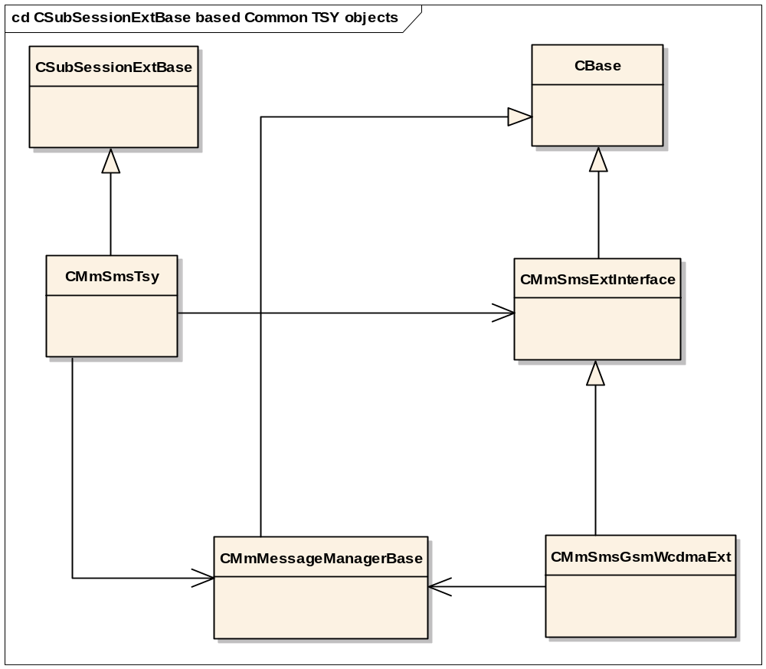
Figure 3.5 CSubSessionExtBase based Common TSY objects (SMS as an example)
There are also subsessions derived from the Symbian OS CSubSessionExtBase class in Common TSY. Those subsessions follow the design presented in Figure 3.5. These subsessions include:
- SMS
- SMS Storage
- USSD
- Broadcast
- Packet data: divided into Context, QoS and Service subsessions
- Conference Call
- Storage: Emergency Number Storage, Own Number Storage and Phonebook Storage

The CMmObjectTsy class is responsible of implementing the Common TSY functionality of the functional unit, for instance SMS or USSD. CMmObjectTsy can access the mode specific functionality via CMmObjectExtInterface, if needed.
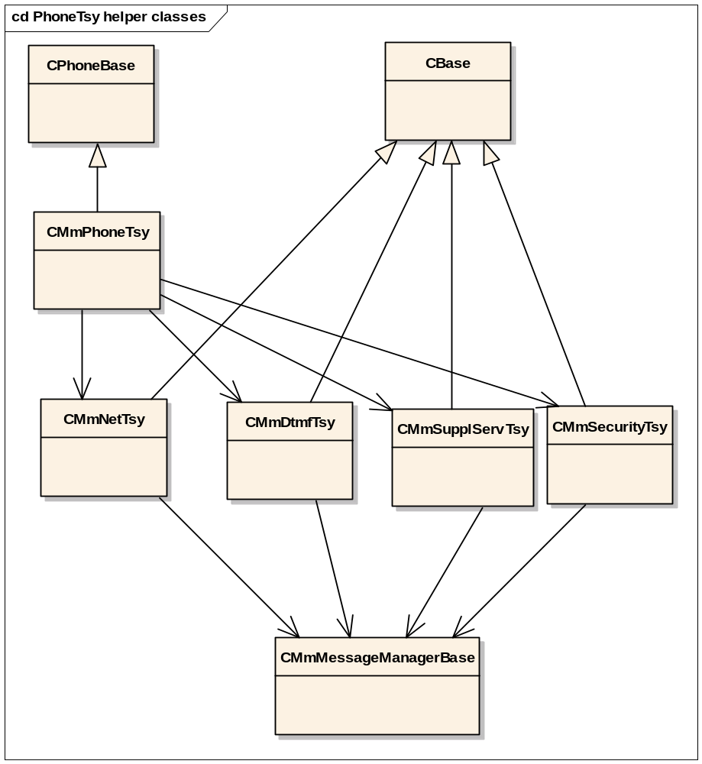
Figure 3.6 PhoneTsy helper classes
CMmPhoneTsy object routes the requests to its helper classes. This mechanism is presented in Figure 3.6. The helper classes implement a specified area of the CMmPhoneTsy functionality. The classes then have access to the Common TSY Plugin API class CMmMessageManagerBase and the requests are routed to Licensee TSY via that class.
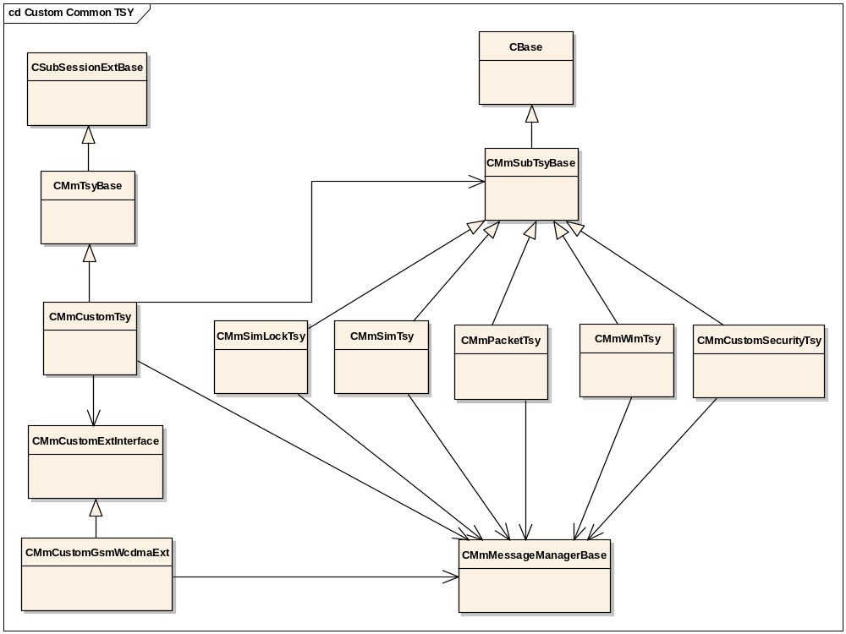
Figure 3.7 Custom Common TSY
The Custom TSY part of Common TSY is presented in Figure 3.7. Custom TSY is divided into five functional units, and it also has CMmCustomExtInterface, which can be called to access mode dependent functionality. Each Custom TSY functional unit routes the client requests to the Common TSY Plugin API independently.
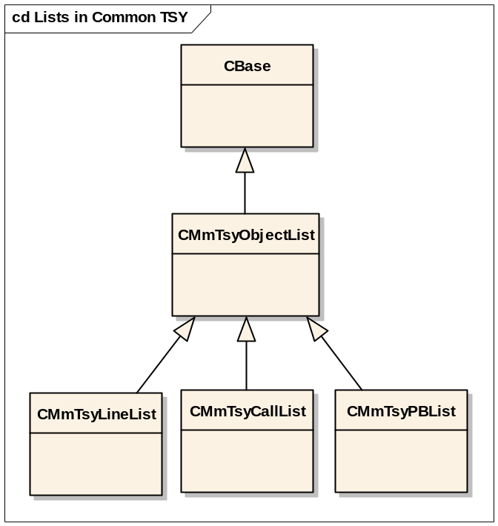
Figure 3.8 Lists in Common TSY
Figure 3.8 shows the list objects that are in use in the Common TSY. The specific line, call or phonebook objects can be accessed via these list classes.

Routing between Common TSY and Licensee TSY – Message Manager
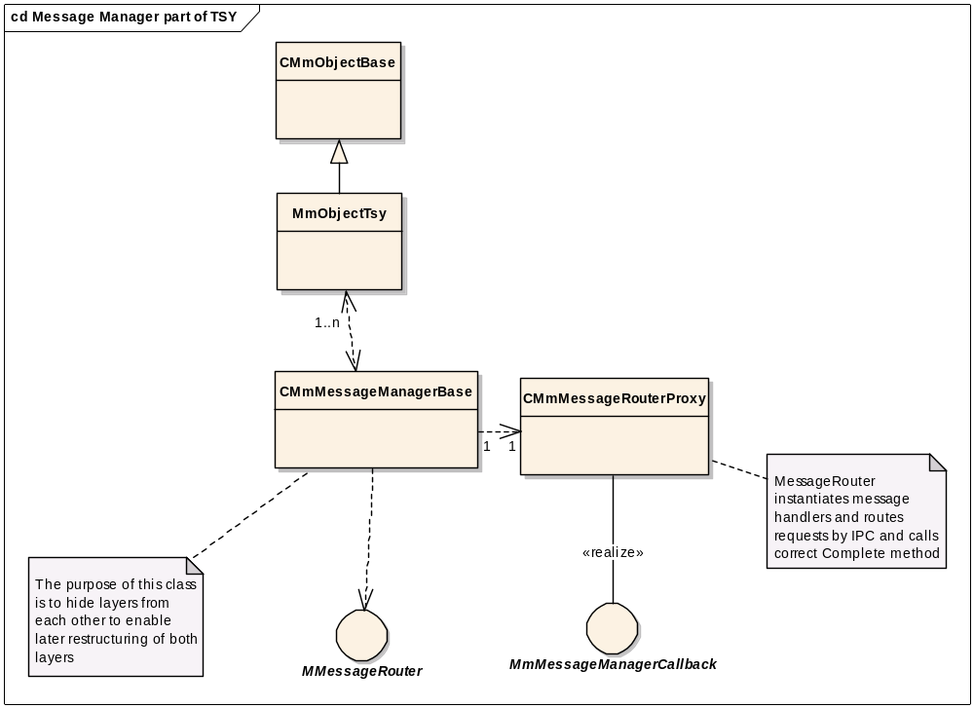
Figure 3.9 Message Manager part of TSY
Figure 3.9 shows the Message Manager and Message Router part of TSY.
The purpose of Message Manager is to separate Common TSY and Licensee TSY from each other (see Section 3.1.1). Message Manager uses Message Router to route requests, responses and indications between the layers.
The requests are routed by Message Router to the correct message handler using the IPC number defined by Symbian Software Ltd. The base routing implementation is provided in the CMmMessageRouterBase class. This routing mechanism allows flexible routing of any feature that requires service from the Baseband to any object in Licensee TSY. This invokes the message clals down to the LTSY via the MMessageRouter interface. This interface would be implemented by licensees.
The responses and indications are routed back to Common TSY via Message Manager and Message Router Proxy. Message Manager decides which object in Common TSY is responsible for handling the response/indication, and Message Router defines which method should be called from that object. This implementation cannot be overwritten by licensees. The purpose of this is to protect Common TSY from strict dependencies to Licensee TSY. The MmMessageManagerCallback interface is used by the licensee TSY to complete responses to the Common TSY.
The data passed from Common TSY to Licensee TSY (and vice versa) is packed as an instance of the CMmDataPackage class. CMmDataPackage is a template class, which provides all the required functionality to pack and unpack one or two objects of any type into a single CMmDataPackage. The purpose of packaging data is to make the API independent of the specific data type of a given request. This packing approach is based on the Symbian TDataPackage class used in the communication between ETel Server and Common TSY. As TDataPackage allows the packing of two parameters at maximum, so does the CMmDataPackage.

Telephony Audio Control between Common TSY and Licensee TSY – Telephony Audio Control

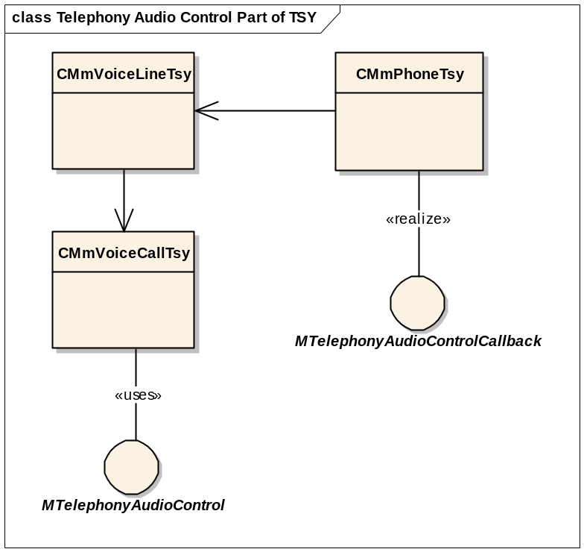
Figure 3.5 Telephony Audio Control part of TSY
Figure 3.5 Shows Telephony Audio Control part of the CTSY, which is optional plug in interface for licensees. The plug in interface is used to inform call creation and destroy by triggering the interface functions in appropriate time. The interface also informs the changes in call state by calling the interface functions when a call moves between its states. There is also a callback interface, MTelephonyAudioControlCallback, which is used to inform errors in audio control to the CTSY.

Class descriptions
Class | Description | Header file
CMmMessageManagerBase | This class forwards request, request completions and notifications from one layer to another, using the routing defined in the CMmMessageRouter / CMmMessageRouterBase class. There is only one object of this type. | CMmMessageManagerBase.h
CMmMessageRouterProxy | The CMmMessageRouterProxy class is responsible for routing indications and responses to the Common TSY objects. Licensees cannot override this implementation. It is owned/managed by Symbian. | CMmMessageRouterProxy.h
CMmDataPackage | This class provides a package/unpackage mechanism to exchange data between the two layers in a type independent way, so that the API remains generic. | CMmDataPackage.h
CMmCallTsy | Handles the call specific mode independent Common TSY functionality. | CMmcalltsy.h
CMmLineTsy | Handles the line specific mode independent Common TSY functionality. | CMmlinetsy.h
CMmPhoneTsy | Handles the phone specific mode independent Common TSY functionality. | CMmphonetsy.h
CMmConferenceCallTsy | Handles the conference call specific Common TSY functionality. | CMmconferencecalltsy.h
CMmPhoneExtInterface, CMmCallExtInterface, CMmLineExtInterface | Interface classes through which the mode dependent functionality of a specified object can be accessed. Allows addition of new mode specific extensions. | CMmphoneextinterface.h, CMmcallextinterface.h, CMmlineextinterface.h
CMmPhoneGsmWcdmaExt, CMmLineGsmWcdmaExt, CMmCallGsmWcdmaExt | GSM/WCDMA specific mode extension classes which handle the mode dependent functionality. | CMmphonegsmwcdmaext.h, CMmlinegsmwcdmaext.h, CMmcallgsmwcdmaext.h
CMmTsyBase | The base class for the Custom TSY objects. | CMmtsybase.h
CMmSubTsyBase | The base class for Custom TSY functional units. | CMmsubtsybase.h
CMmSimLockTsy, CMmSimTsy, CMmWimTsy, CMmPacketTsy, CMmCustomSecurityTsy | Custom TSY functional units. | CMmsimlocktsy.h, CMmsimtsy.h, CMmwimtsy.h, CMmpackettsy.h, CMmcustomsecuritytsy.h
CMmPhoneFactory | The Phone Factory class instantiated by Common TSY. This object is called by ETel Server when TSY is instantiated and a phone object is created. | CMmphonefactory.h
CMmDtmfTsy, CMmNetTsy, CMmSupplServTsy, CMmSecurityTsy | CMmPhoneTsy routes the client requests to these classes. | CMmdtmftsy.h, CMmnettsy.h, CMmsupplservtsy.h, CMmsecuritytsy.h
CMmTsyObjectList | The base class for the Common TSY lists. | CMmtsyobjectlist.h
CMmTsyLineList | Contains a list of all line objects currently open from the Phone module. | CMmtsylinelist.h
CMmTsyCallList | Contains all call objects currently open from all lines except the ones reserved for next incoming calls. | CMmtsycalllist.h
CMmTsyPBList | Contains a list of currently open phonebooks in Common TSY. | CMmtsyPBlist.h
CMmPacketServiceTsy | Handles the packet service specific mode independent Common TSY functionality. | Cmmpacketservicetsy.h
CMmPacketServiceGsmWcdmaExt | GSM/WCDMA specific mode extension classes which handle the mode dependent functionality. | cmmpacketservicegsmwcdmaext.h
CMmPacketContextTsy | Handles the PDP context specific mode independent Common TSY functionality. | Cmmpacketcontexttsy.h
CMmPacketContextGsmWcdmaExt | GSM/WCDMA specific mode extension classes which handle the mode dependent functionality. | cmmpacketcontextgsmwcdmaext.h
CMmPacketContextList | Contains a list of all PDP context objects currently open from the Packet Service module. | Cmmpacketcontextlist.h
CMmPacketQoSTsy | Handles the Quality of Service specific mode independent Common TSY functionality. | Cmmpacketqostsy.h
CMmPacketQoSGsmWcdmaExt | GSM/WCDMA specific mode extension classes which handle the mode dependent functionality. | cmmpacketqosgsmwcdmaext.h
CMmMBMSContextTsy | Handles the MBMS context specific mode independent Common TSY functionality. | cmmmbmscontexttsy.h
CMmMBMSContextList | Contains a list of all MBMS context objects currently open from the Packet Service module. | CMmMBMSContextList.h
CMmMBMSMonitoredList | Contains a list of all active MBMS services. | CMmMBMSMonitoredList.h
MTelephonyAudioControl | Interface which is triggered when calls are created and destroyed and when the call moves between its states. | MMmTelephonyAudioControl.h
MTelephonyAudioControlCallback | Interface which is used to inform errors in Telephony Audio Control to the CTSY. | MMmTelephonyAudioControlCallback.h

Structs, type definitions and enumerations

<CMmDataPackage.h> CMmDataPackage

CMmDataPackage | Description
PackData | Packages one or two parameters of different type (specified as template parameters) into a CMmDataPackage object.
UnPackData | Unpacks one or two parameters of different type (specified as template parameters) from CMmDataPackageObject.

Flag definitions
This section specifies the flags (feature, debug etc. flags) used by the subsystem and clarifies their usage.

Flag | Description
__COMMON_TSY_EMERGENCY_CALLS_ENABLED_IN_OFFLINE_MODE | When this flag is enabled, it is possible to dial an emergency call even when in the Offline mode.
__CS_VIDEO_TELEPHONY | When this flag is enabled, the device supports circuit switched video telephony.

The state of these flags can be changed in the bldvariant.hrh file. These flags are not used in Common TSY as such but through the Feature Manager API (dynamic variability).

State diagrams
Call related state diagrams can be found from reference document [R1].

Operations

Initializing a connection to the Baseband

Operation | Initializing a connection to the Baseband.
Preconditions | A client is ready to load the TSY module. The Baseband is ready to be called.
Description | TSY initializes its framework. Message Manager and Message Router are created. All message handlers are created. A connection to the Baseband is opened.
Inputs | The name of the TSY module and the name of the Phone object.
Modifies | Creates an instance of CMmPhoneTsy, which creates CMmMessageManager. CMmMessageManager in its turn creates CMmMessageRouter. CMmMessageRouter creates the instances of all required message handlers.
Outputs | A success/failure result value to the client.
Postconditions | TSY is loaded. A channel to the Baseband has been opened and is ready to be used.
Related to | The following classes: CMmPhoneTsy, CMmMessageManager, CMmMessageManagerBase, CMmMessageRouter, CMmMessageRouterBase.
Related event | None
Exceptions | Multiple exception scenarios are possible. Input name(s) could be wrong, connection to the Baseband could fail, memory allocation could fail etc.

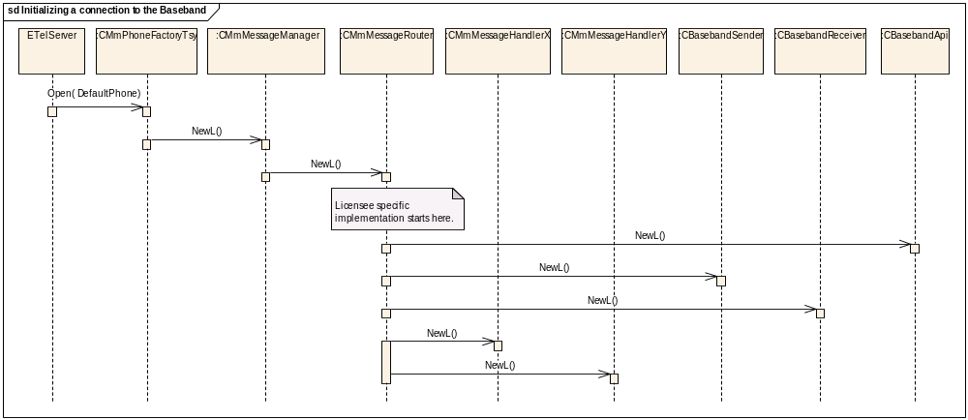
Figure 3.10 Initializing a connection to the Baseband

Serving an ETel API request

Operation | Serving an ETel API request.
Preconditions | TSY is loaded.
Description | An example of a sequence for serving an ETel API request.
Inputs | Request handle and necessary request parameters.
Modifies | The state of Common TSY.
Outputs | The client is notified about the status of the request.
Postconditions | The request is served.
Related to | The following classes: CMmObjectTsy, CMmObjectExtInterface, CMmMessageManagerBase, CMmMessageManager, CMmMessageRouterBase, CMmMessageRouter, CMmMessageHandlerX, CBasebandSender, CBasebandReceiver.
Related event | None
Exceptions | The request fails. The client is notified about this.

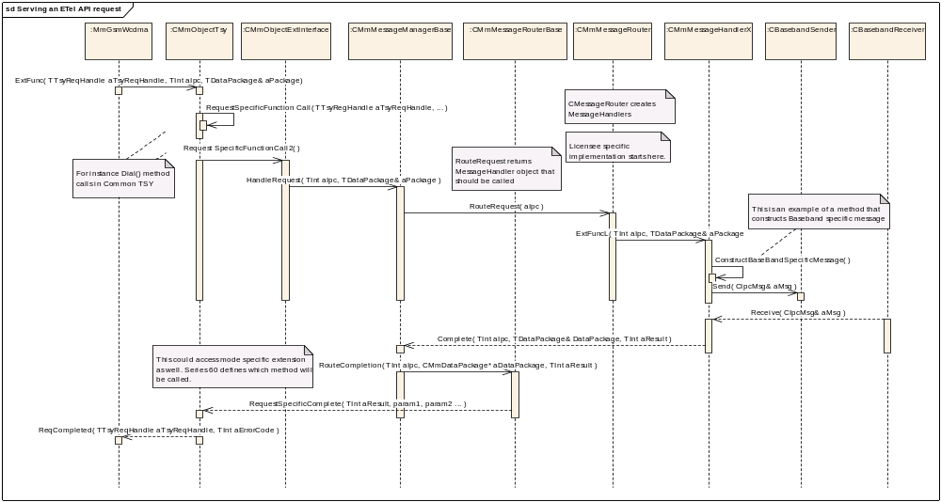
Figure 3.11 Serving an ETel API request
The ETel Multimode API request enters Phone TSY, to the object of type CMmPhoneTsy. The mode specific extension object (of type CMmCallGsmWcdmaExt) has to use the Baseband to fulfill the request, so it uses Message Manager to handle the request. Message Manager hides the information about which Licensee TSY object is handling the request.
Message Manager calls Message Router to route the request to a message handler using the IPC. This routing mechanism allows Symbian licensees to overwrite which message handler the request should be routed to. After this, the message handler is accessed by calling the ExtFunc method (licensees can overwrite this if necessary), which enables reusing common code for all requests (for example, start using the send buffer and sending the Baseband message).
When a response is received from the Baseband, the request is routed back to Common TSY using the Complete method from Message Manager. Message Manager gets the correct Common TSY object using the IPC number, and uses Message Router to call the correct method from that object (using the IPC number again). Since Licensee TSY does not call the Common TSY implementation directly, re-factoring the layers is possible.

Serving an ETel API notification request

Operation | Serving an ETel API notification request.
Preconditions | TSY is loaded.
Description | An example of the sequence for serving an ETel API notification request.
Inputs | Request handle and necessary request parameters.
Modifies | The state of the Common TSY.
Outputs | The client is notified about the status of the notification request when the notification arrives from the Baseband.
Postconditions | The notification is completed.
Related to | The following classes: CMmObjectTsy, CMmObjectExtInterface, CMmMessageManagerBase, CMmMessageManager, CMmMessageRouterBase, CMmMessageRouter, CMmMessageHandlerX, CBasebandSender, CBasebandReceiver.
Related event | None
Exceptions | The request fails. The client is notified about this.

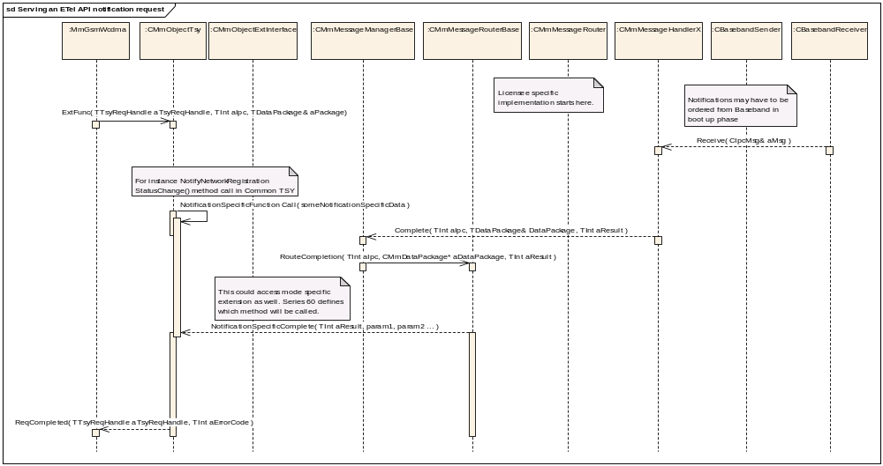
Figure 3.12 Serving an ETel API notification request

The notification request works on the Common TSY level much in the same way as the normal request, which is described in Figure 3.1. The main difference is that a notification request does not have to be forwarded to Licensee TSY at all. Common TSY will update its internal state in order to complete the needed notifications to clients that have registered for those notifications. Completing the notifications works similarly to completing the normal requests.

Backup and Restore
This component does not participate in Backup and Restore.

IPC Naming Conventions
The following naming conventions will be used for any new IPC messages between the Common TSY and the LTSY:
Direction of message | Meaning | Convention | Example
CTSY to LTSY | Synchronous IPC message.  Returns an error code.  No data is returned. | ECtsy<xxxx>Sync | ECtsyCellInfoSync
CTSY to LTSY | Asynchronous IPC message.  Expect a Complete message from LTSY. | ECtsy<xxxx>Req | ECtsyCellInfoReq
LTSY to CTSY | Asynchronous completion of previously requested “Req” IPC | ECtsy<xxxx>Comp | ECtsyCellInfoComp
LTSY to CTSY | Unsolicited event notification | ECtsy<xxxx>Ind | ECtsyCellInfoInd

Caching Pattern
The efficiency of the Common TSY is improved by caching data received from the LTSY. This way, client requests can be completed straight away without going down to the LTSY if the cache is up to date.

Requirements
For any cached LTSY data, the Common TSY needs to:
- Keep track of the cache state (clean/dirty).
- Keep track of the cache ability (enabled/disabled).
- Support no notification ability by the LTSY for that data (always disabled).
- Support ability to delay enabling of caching (temporarily disabled).
- Support temporary suspension of caching ability (temporarily disabled).
- Handle notifications from the LTSY when data changes and update cache accordingly.
- Retrieve cached data from LTSY when cache state is dirty.

Applying IPC naming conventions to caching IPCs
The following types of IPCs will be used (see Section 4 for naming convention details):
- The CTSY will send a “Req” message to request the data from the LTSY.
- The LTSY will send a “Comp” message to complete the CTSY data request message.
- The CTSY will send another “Req” message (“IndReq”) to request data change notifications from the LTSY.
- The LTSY will send a “Comp” message to inform the CTSY of its ability to send automatic change notifications.
- The LTSY will send an “Ind” IPC to notify the CTSY of data changes.

Get requests
_
sd Get IPC
_
ETel
_
CTSY
_
LTSY
_
Baseband
opt Request Notifications
[CacheAbility == Unknown]
opt Refresh Cache
[(CacheAbility == Disabled) || (CacheState == Dirty)]
alt Return cached data
[(CacheAbility == Enabled) && (CacheState == Clean)]
_
ETel Client
_
The Get Request and the Notification
_
Request can complete in either order
GetCellInfo
ExtFunc(EMobilePhoneGetCellInfo)
CacheAbility(ECtsyCacheCellInfo)
ExtFunc(ECtsyGetCellInfoIndReq)
RegisterCellInfoChangeNotifications
Complete
Complete(ECtsyGetCellInfoIndReq,result)
SetCacheAbility(ECtsyCacheCellInfo,
TBool aAbility)
ExtFunc(ECtsyGetCellInfoReq, data)
Complete(ECtsyGetCellInfo, data)
SetCacheState(ECtsyCacheCellInfo,
aCacheState)
GetCachedData
Complete(EMobilePhoneGetCellInfo)
Complete(EMobilePhoneGetCellInfo)

Register requests and LTSY notifications
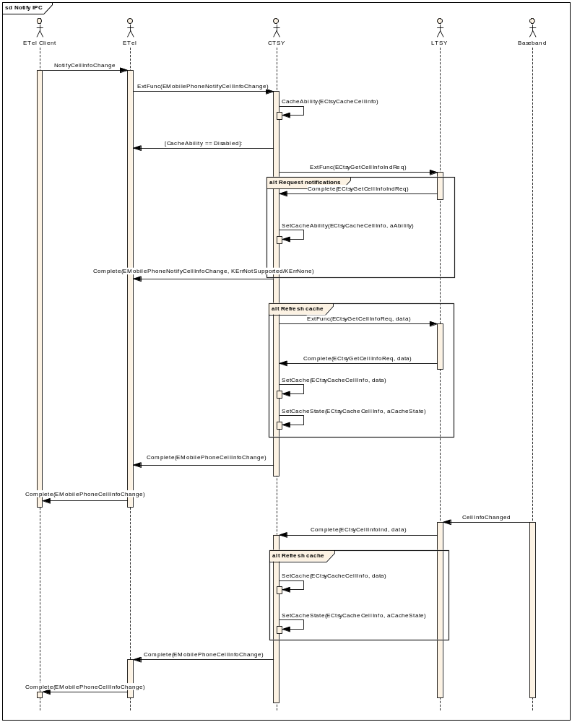

Legacy IPC handling
At the moment, already existing requests assume that cached data is always up to date. When the CTSY receives a Get request it checks if the cached data structure is “set”. If it is not, it will request the data from the LTSY. If it is set, it will just assume that it is up to date and complete it to the client.

Cached data
The cached data is encapsulated in a new class called TCachedAttribute, along with the status of the cache.
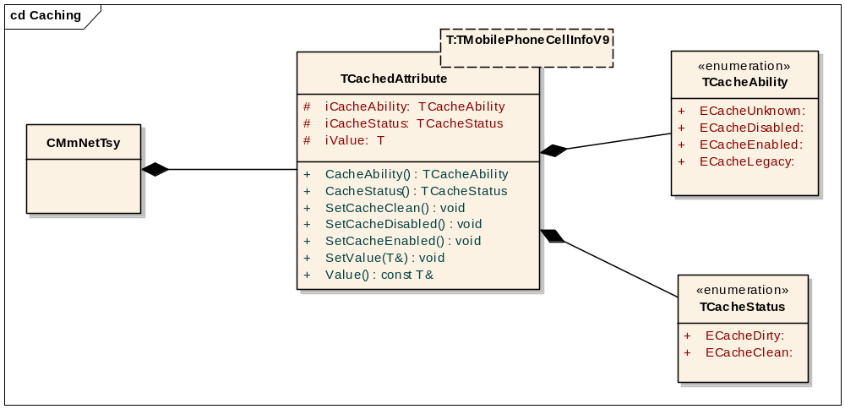

TCacheAbility | Description
ECacheUnknown | Initial value of the caching ability.
ECacheDisabled | Caching is disabled. This is typically because the LTSY does not have the capabilities to send automatic change notifications.
ECacheEnabled | Caching is enabled. The LTSY is capable of receiving change notifications from the baseband and notify the CTSY.
ECacheLegacy | It is always assumed that cached value is up to date.

TCacheStatus | Description
ECacheDirty | There is no guarantee that the cached data is up to date.
ECacheClean | The cached data is up to date.

Cache Ability state transitions (enabled/disabled/legacy)
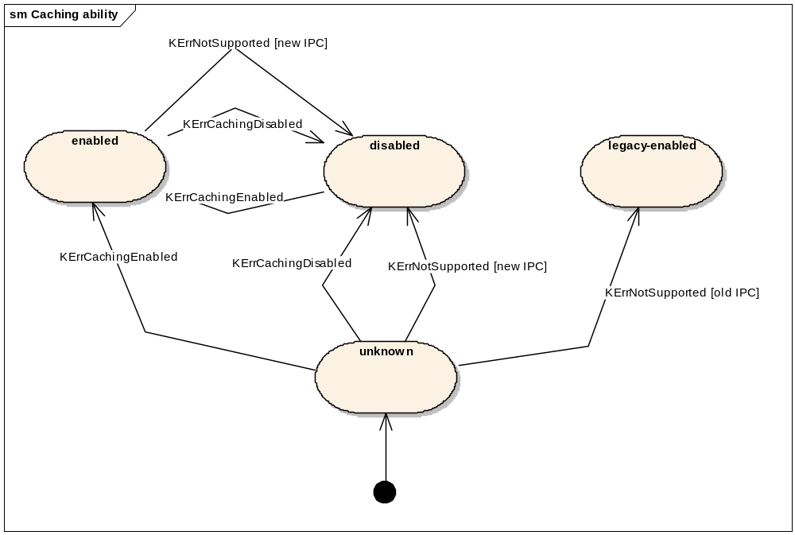

Cache Status state transitions (clean/dirty)
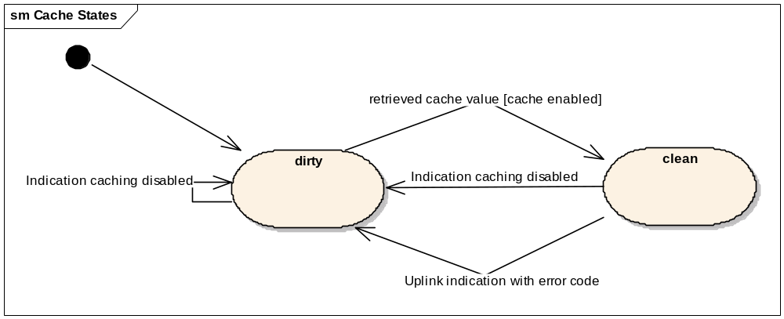
Figure 6 Cache Status state transitions: status can be dirty or clean

Design Considerations

System resource usage

Files
Common TSY uses file writing capabilities for test log writing purposes.
The SIM authentication functionality uses two files to save the current and previous authentication keys used. The File Server client side API is used to create, save, edit and read the files at runtime.
There is also one initialization file where it is possible to define whether the ciphering indicator showing is permanently set off or not. This file is only read by the Common TSY component.

Other data

Databases
This component does not use any databases.

Central Repository
This component does not use Central Repository.

Publish and Subscribe
This component does not use Publish and Subscribe.

Task allocation
Common TSY and ETel Server run in the same thread that belongs to the Communications process of the Symbian OS.

Performance
The most performance critical phase for Common TSY is the boot-up phase. This phase should not take too long, as the boot-up time is a critical feature for a mobile phone. Common TSY has been designed to make as few time consuming actions (such as file reading, etc.) as possible in the boot-up phase to minimize the time taken to boot up the device.

Timers

Timer | Purpose | Interval | Lifetime
Request timer | To complete a request that has not been completed in a reasonable amount of time. | One second | When a request is pending. Is stopped when the request is completed.

Security

Capabilities of this component
Capability | Justification
CommDD PowerMgmt ReadDeviceData WriteDeviceData TrustedUI ProtServ NetworkControl NetworkServices LocalServices ReadUserData WriteUserData | Common TSY has to have enough trust, a.k.a capabilities, so that the Communications process is able to load it dynamically.

Input and output validation
Common TSY does the input validation for incoming data from the ETel API client according to the ETel specifications. It is also a Common TSY responsibility to send valid data back to the clients.
For the Common TSY Plugin API, it is the responsibility of the caller of the API to provide valid data to the API.

Additional enforcements
This component does not have any additional security enforcements.

Variation
Common TSY is not a mandatory part of Symbian and can therefore be included or excluded from a ROM image at image creation time.
Common TSY supports dynamic variation through the Feature Manager API for the emergency calls allowed in the Offline Mode implementation.

Usage

User's guide

From the ETel Server client point of view
Reference document [R1] provided by Symbian is the user guide for ETel API client interaction.

From the Licensee TSY point of view
Reference document [R2] is the user guide for implementing the Licensee TSY and reference document for implementing SIM ATK TSY.

Introducing the CTSY Dispatcher
To simplify LTSY development a new layer has been provided under the existing CTSY that is being developed and maintained by Symbian, the purposes of which are:
- Reduce code base for licensee LTSY by hiding all packing and unpacking functionality that is necessary for each IPC exchanged between CTSY and LTSY
- Present a simple to use function based interface that allows for rapid development by licensee engineers who are likely to be unfamiliar with Symbian Telephony and possibly even Symbian OS principles.
- To clean up data exchanged between CTSY and LTSY such that [in] and [out] arguments are clearly documented
- (Where possible) Simplify the callback logic (for events sent by LTSY to CTSY) to remove hidden ordering dependencies. E.g. Hide from LTSY CTSY internal requirements that may impose callbacks to be made in a specific order.
This has resulted in the introduction of a new layer beneath the existing CTSY that is referred to as the CTsyDispatcher layer. This layer implements the existing CTSY-LTSY interface including the packing and unpacking of IPC data and makes requests down to LTSY for actual servicing. The LTSY will still handle the translation to the appropriate baseband requests. The LTSY is being provided with a callback interface to be used for completions to enable it to pass data and event information up to the CTsyDispatcher. The CtsyDispatcher then packs this into the appropriate {IPC, data} for sending to the CTSY.

New Component View
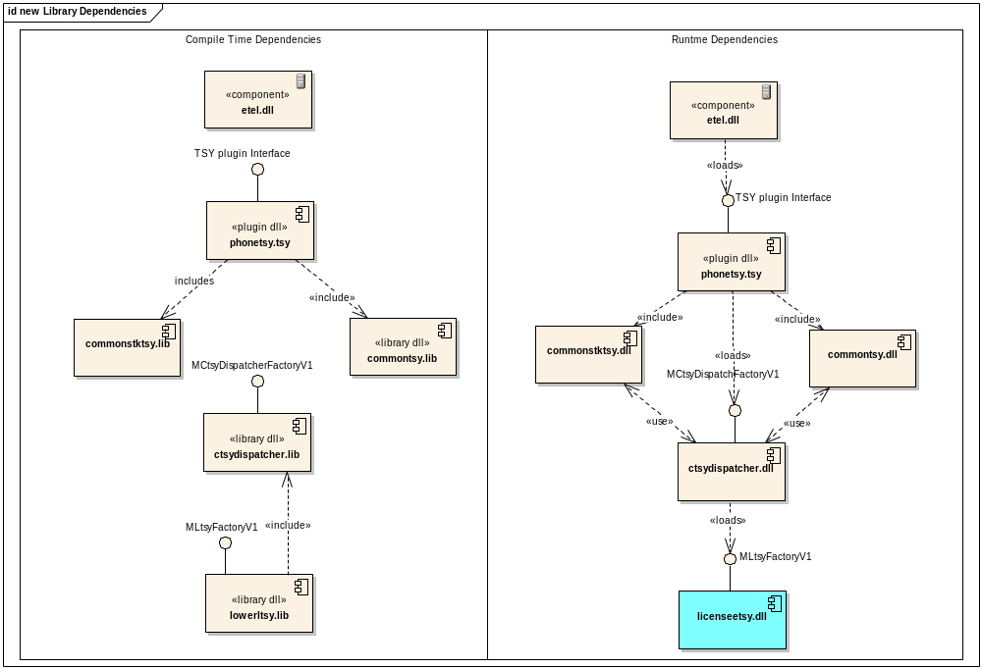
Figure 7 Dependencies in new LTSY architecture
The main thing to note with the addition the ctsydispatcher.dll is that it’s now the component that will load the licenseetsy.dll. Note lowerltsy.lib refers to whichever library is relevant for the licensee to load, in the testing case this is licenseeskeletontsy.lib.

CtsyDispatcher-LicenseeTSY Interface
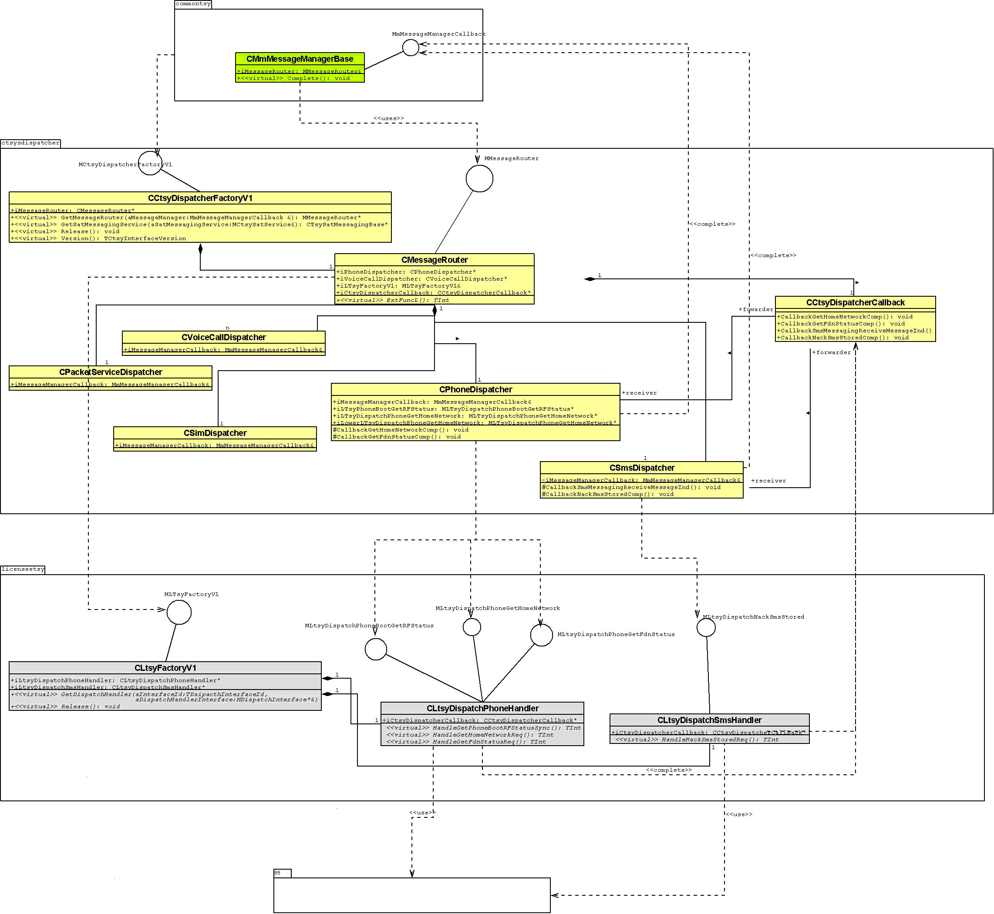
Figure 8 CtsyDispatcher and LTSY class view

Figure 8 above depicts the key classes that are present in the new interface.

Class | Layer | Role
CMmMessageManagerBase | CTSY | Manages message passing between CTSY and CtsyDispatcher. Implements the CTSY callback interface MmMessageManagerCallback
CLtsyFactoryV1 | CtsyDispatcher | Factory class that is responsible for creation of interfaces when requested by the CTSY.  Implements the MLTsyFactoryV1 interface.
CMessageRouter | CtsyDispatcher | This is the top level class for receiving messages from the CTSY. It implements the ExtFunc method that is invoked by the CTSY when sending a message to the CtsyDispatcher.  Implements the MMessageRouter interface.
CLtsyXXXDispatcher | CtsyDispatcher | Examples: CPackertServiceDispatcher, CVoiceCallDispatcher, CSmsDispatcher.  These are called dispatcher classes and have the responsibility of handling messages (forwarded from CMessageRouter) and doing the unpacking (from CMmDataPackage) before invoking the relevant API call down to the LTSY.  Their second responsibility is to handle the callbacks from the LTSY resulting from either request completions or event indications. The LTSY uses the methods available from CCtsyDispatcherCallback to trigger a callback that is routed to the relevant CXXXDispatcher to handle. The dispatcher would pack the data into a CMmDataContainer and send a Complete request message to the CTSY.  Dispatcher classes would be created for each functional area e.g. SMS, packet, cell broadcast etc.
CCtsyDispatcherCallback | CtsyDispatcher | This class presents a set of methods that allow the LTSY to callback into the CtsyDispatcher as a result of either a request completion or event completion.  A pointer to this instance shall be passed down to the LTSY during construction for use.
CLtsyFactoryV1 | LTSY | This class has the responsibility to create instances of all the interfaces when requested by the CtsyDispatcher.  It implements the MLtsyfactoryV1 interface.
CLtsyDispatchXXXHandler | LTSY | Examples: CLtsyDispatchPhoneHandler, CLtsySmsHandler.  For each functional area a handler class should be provided that implements all the interface methods for that specific functional area.  It is these handler classes that form the bulk of the LTSY and translate the request made by the CtsyDispatcher to one or more Baseband calls.  Each instance of CLtsyDispatchXXXHandler should hold a reference to the CCtsyDispatcherCallback to enable completions and events to passed back up to the CtsyDispatcher for processing.

The dispatcher classes are organised into functional units. In all, there are 14.
Functional Unit | Dispatcher Class
Call Control | CCallControlDispatcher
Phone | CPhoneDispatcher
Security | CSecurityDispatcher
EN Phonebook store | CPhonebookEnDispatcher
Cell Broadcast | CCellBroadcastDispatcher
ON Phonebook Store | CPhonebookOnDispatcher
Phonebook store | CPhonebookDispatcher
Sim | CSimDispatcher
Sms | CSmsDispatcher
Multiparty Call Control | CCallControlMultipartyDispatcher
Supplementary Services | CSupplementaryServicesDispatcher
Packet Services | CPacketServicesDispatcher
SAT | CSatDispatcher

The introduction of the CtsyDispatcher in effect provides a function based interface to be implemented by the LTSY. Each IPC message that is sent by the CTSY and subsequently unpacked by the CtsyDispatcher would be then mapped to the appropriate interface function call as shown in figure below.
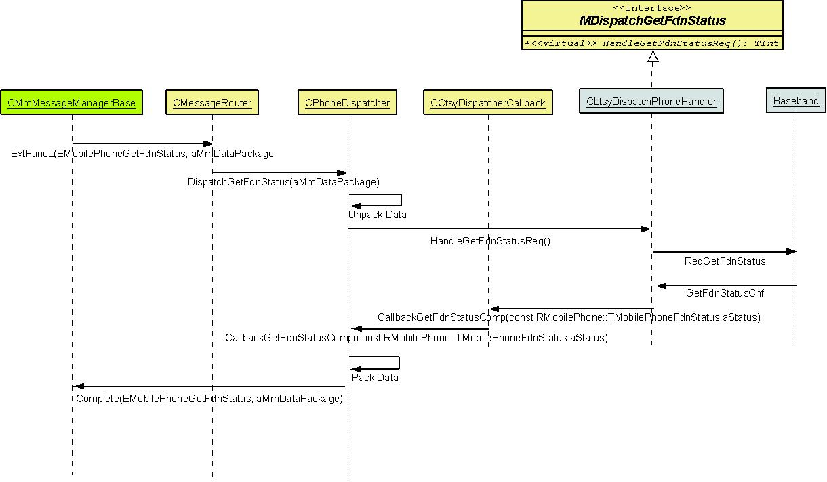

Figure 9 Sequence flow between CtsyDispatcher and LTSY

As an example the table below shows a few mapping between IPC’s and the interface function to be implemented by the LTSY.
Message IPC | Interface mapping | Code snippet
EEtelCallAnswer | MLtsyDispatchCallControlAnswer | class MLtsyDispatchCallControlAnswer  {  /** Implement this interface to handle call answer requests  @param aCallId ID call to answer  @param aService service type @see RMobilePhone::TMobileService  @return TInt KErrNone on successful handling. KErrNotSupported if not supported. Or some other Symbian general error code.  */  virtual TInt HandleAnswerReqL(TInt aCalld, RMobilePhone::TMobileService aService) = 0;  };
EMobileCallHold | MLtsyDispatchCallControlHold | class MLtsyDispatchCallControlHold  {  /** Implement this interface to handle call hold request  @param aCallId ID call to put on hold.  @return TInt KErrNone on successful handling. KErrNotSupported if not supported. Or some other Symbian general error code.  */  virtual TInt HandleHoldReqL(TInt aCalld) = 0;  };
EMobilePhoneGetHomeNetwork | MLtsyDispatchPhoneGetHomeNetwork | class MLtsyDispatchPhoneGetHomeNetwork  {  /** Implement this interface to handle request to get home network  @return TInt KErrNone on successful handling. KErrNotSupported if not supported. Or some other Symbian general error code.  */  virtual TInt HandleGetHomeNetworkReqL () = 0;  };

For the callback the LTSY is provided with a pointer to CCtsyDispatcherCallback which has a method for each event or completion needing to be triggered. The unsolicited callbacks (event notifications) would then map directly to an IPC message to be completed to the CTSY as shown by the example mappings below.
Completion Message IPC | Callback function mapping to use | Code snippet
EMobilePhoneNotifyCurrentNetworkChange | CCtsyDispatcherCallback:: CallbackPhoneNotifyCurrentNetworkChangeInd | /** Callback to be used to indicate change in network information.  @param aNewNetworkInfo Contains new network information. @see RMobilePhone::TMobilePhoneNetworkInfoV1  */  EXPORT_C void CCtsyDispatcherCallback:: CallbackPhoneNotifyCurrentNetworkChangeInd (const RMobilePhone::TMobilePhoneNetworkInfoV1& aNew NetworkInfo);
EMobilePhoneNotifyModeChange | CCtsyDispatcheCallback:: CallbackPhoneNotifyNetworkModeChangeInd | /** Callback to be used to indicate change in network mode  @param aNewNetworkMode Contains new network mode. @see RMobiePhone::TMobilePhoneNetworkMode for mode types  */  EXPORT_C void CCtsyDispatcherCallback:: CallbackPhoneNotifyNetworkModeChangeInd (RMobilePhone::TMobilePhoneNetworkMode aNew NetworkMode);
EMobilePhoneNotifySignalStrengthChange | CCtsyDispatcherCallback:: CallbackPhoneNotifySignalStrengthChangeInd | /** Callback to be used to indicate changes in signal strength  @param aSignalBars New signal strength  @param aBars New bars to display.  */  EXPORT_C void CtsyDispatcherCallback:: CallbackPhoneNotifySignalStrengthChangeInd (TUInt aNewSignalStrength, TUint8 aNewBars);

Both HAIs are available for use and remain fully supported. A Licensee can choose which HAI to use and include the appropriate DLLs into their ROM. By default CTSY will build both variants so they are readily available.
For more details on using the Dispatcher layer see reference [R7].

Further Information

References
No. | Document Reference | Version | Description
[R1] | Multimode ETel API Design Document |  | Symbian OS guide » Telephony » ETel Multimode engineering documents » Multimode ETel API Design Document
[R2] | Common TSY Implementation Guideline |  | Common_TSY_How_To_Implementation_Guideline.doc
[R3] | Common TSY Common TSY Subsystem Architecture Description |  | Common_TSY_Common_TSY_Subsystem_Architecture_Description.doc
[R4] | Common TSY Common TSY Plug-in API Specification |  | Common_TSY_Plugin_API_Specification.doc
[R5] | Common TSY Multimode ETel Custom API Design Document |  | Common_TSY_Multimode_ETel_Custom_API_Design.doc
[R6] | ETel Core API Design Document |  | Symbian OS guide » Telephony » ETel 3rd Party API engineering documents » ETel Core API Design
[R7] | ETel Packet API Design Document |  | » Symbian OS guide » Telephony » Etelpckt engineering documents » Multimode ETel Packet Data API Design Document
[R8] | How-to Write a LTSY |  | How-to write a LTSY.doc

Open Issues

Glossary
Term | Definition
ETel | EPOC Telephony Server
HAI | Hardware Adaptation Interface
IPC | Inter-process Communication
RF | Radio Frequency
SAT | SIM Application Toolkit
TSY | Symbian OS Telephony Subsystem
UI | User Interface
Multimode ETel Custom API | Common TSY specific extension to ETel APIs.

Document History
Date | Version | Status | Author | Description
17-02-2009 | 1.4 | Issued | Rob Pallister | Added Dispatcher
10-12-2008 | 1.3 | Issued | Ilkka Ketonen | Added Telephony Audio Control
14-07-2008 | 1.2 | Issued | Olavi Illikainen | Packet and MBMS classes added
23-05-2008 | 1.1 | Issued | Oscar Gonzalez | IPC naming conventions and caching pattern
26-02-2008 | 1.0 | Issued | Mike Corlett | System State Manager
05-11-2007 | 0.1 | Draft | Neil McAlpine | First Draft

